Watching a film in English: “Rabbit-proof fence”

Pre-watching tasks:
- Do some research and complete this map with the following details:
- rabbit-proof fence 1-3
- the towns: “Perth“, “Jigalong”, “Meekatharra” and “Wiluna”
Your English book might be helpful or you can do your research online

- Read the quotes on the back. Talk to your neighbour about them and guess
what the film might be about.

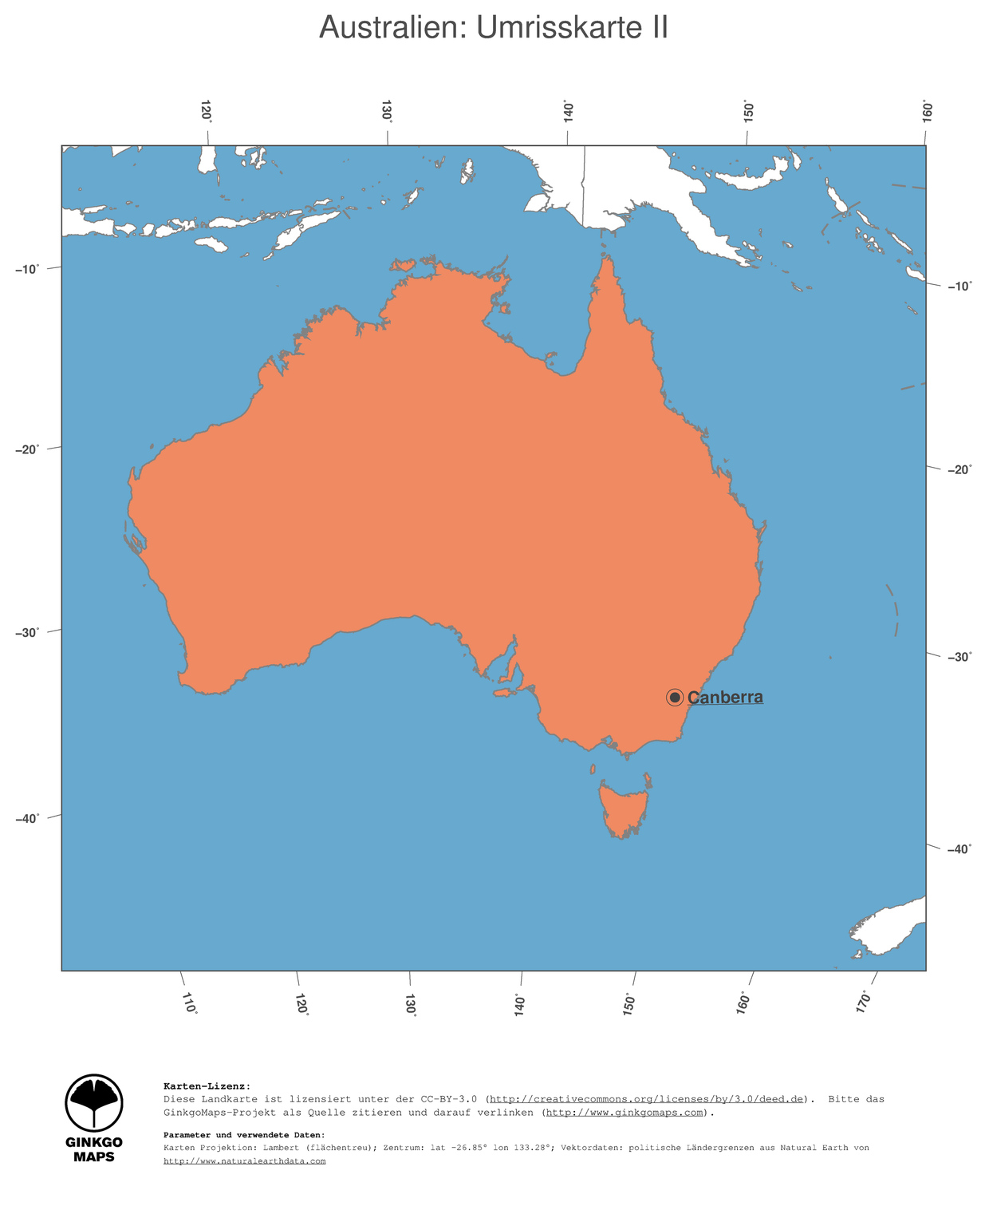
Quotes from the film:

“See that bird? That's the spirit bird. He will always look after you.“

”These people... make me sick!“

“This is your new home. We don't use that jabba (Gequassel) here. You speak English.“

”If only they would understand what we are trying to do for them.“

“Mr. A. O. Neville, the Chief Protector of Aborigines, is the legal guardian (Erziehungsberechtigter/Vormund) of every Aborigine in the State of Western Australia.“

“This girl is clever. She wants to go home.“

source: DVD rabbit-proof fence 2001.

