Links IKK
Power Point Intercultural Communication (iceberg) 5.41
https://www.youtube.com/watch?v=SkBXaKfxl7Y

Multiculturalism in the Modern World: Jen Holladay at TEDxDenverTeachers 14.49
Understanding and embracing multiculturalism and teaching students cultural competency is critical for competing and succeeding in our diverse democracy. How can you ensure that cultural competency is an outcome of your students' education? Presented by Jen Holladay, Highline Academy Charter School Board President.
https://www.youtube.com/watch?v=U5rKgDOs33U

Intercultural communication skills
https://www.skillsyouneed.com/ips/intercultural-communication.html 15.25

Your intercultural communication skills. Five ways to improve.
http://www.englishandculture.com/blog/bid/71208/Your-Intercultural-Communication-Skills-5-Ways-to-Improve 15.27

Pros and cons of living in NZ 12.36
https://www.youtube.com/watch?v=NX-cPZX4i2w

Intercultural Communication New Zealand 8.50
https://www.youtube.com/watch?v=cu5z57yfBD8

British vs. American series
School! British VS American! | Evan Edinger & Emma Blackery 12.57
https://www.youtube.com/watch?v=XBKZnFdrOBs

Waiting Tables! British VS American | Evan Edinger & Emma Blackery 11.10
https://www.youtube.com/watch?v=oo5x8GEXgTQ

Prom or Ball? | British VS American | Evan Edinger & Dodie Clark & Noodlerella 14.36
https://www.youtube.com/watch?v=R2qy6FdVbQk

https://www.youtube.com/watch?v=FNvujF9BEZg
Food! British VS American | Evan Edinger & Dodie Clark & Savannah Brown 18.09

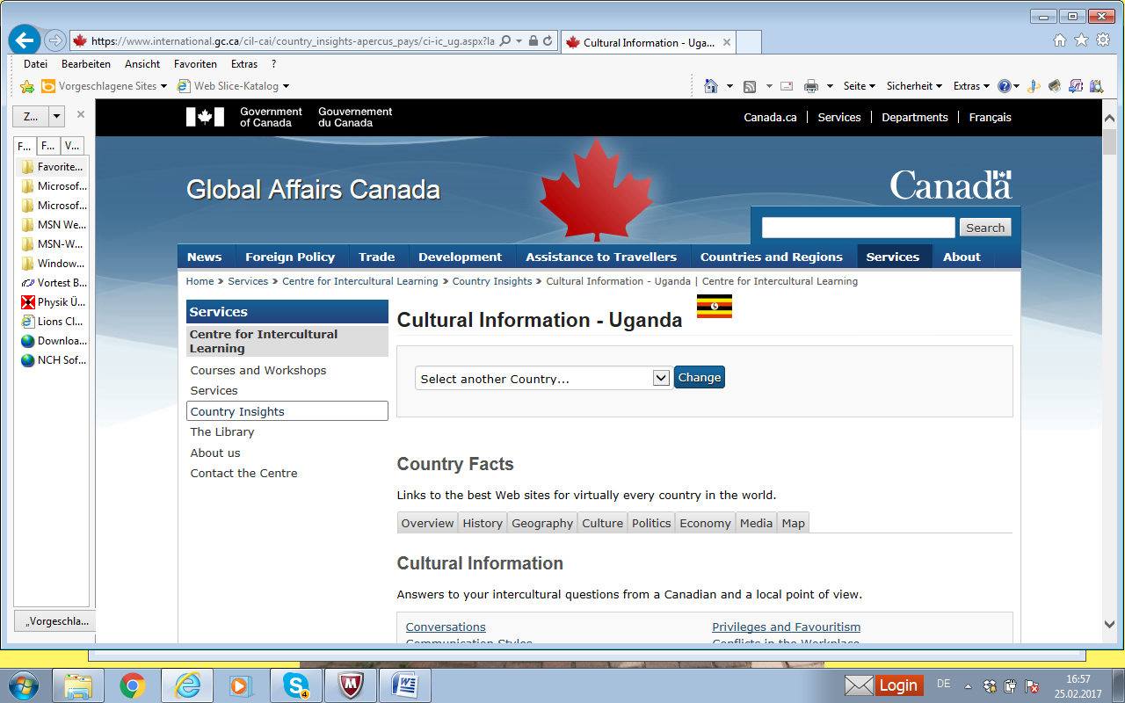
https://www.international.gc.ca/cil-cai/country_insights-apercus_pays/ci-ic_ug.aspx?lang=eng

School! British VS American! | Evan Edinger & Emma Blackery 12.57
https://www.youtube.com/watch?v=XBKZnFdrOBs

Differences between British and American culture (UK vs USA) 5.06
https://www.youtube.com/watch?v=krEO7nGknwI

Differences between British and American schools (UK vs USA) 5.55
https://www.youtube.com/watch?v=viYfEOE-Y_w

Differences between American and British grocery stores (UK vs USA grocery stores)4.39
https://www.youtube.com/watch?v=5mgZV0vynAA

British vs America: How We Do It 9.49
https://www.youtube.com/watch?v=bmHcJnd5j9U

