202_01 world of work pics

Photo by Elevate on Unsplash
https://unsplash.com/photos/yj_o0Vn7TSY

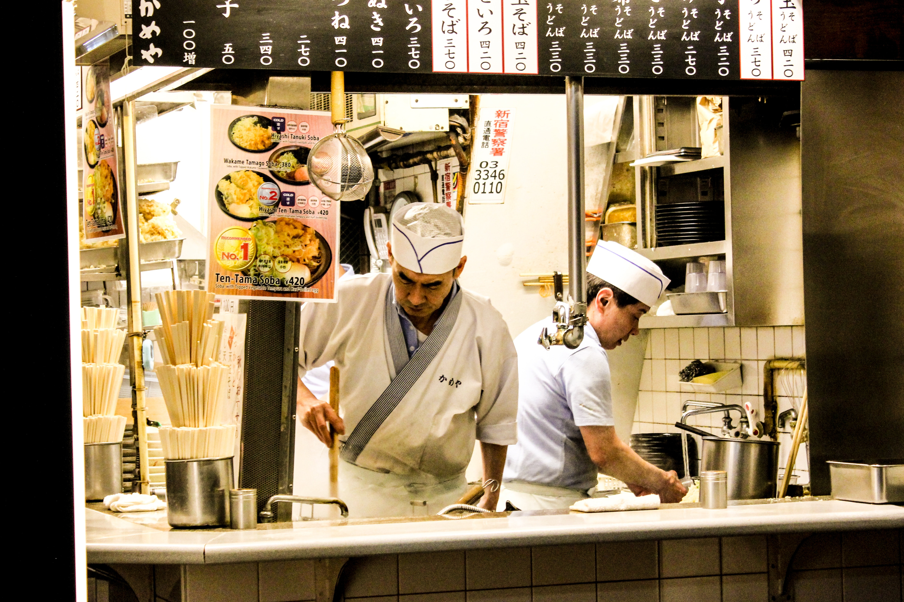

Photo by Emran Yousof on Unsplash
https://unsplash.com/photos/k8ZbMQWbx34

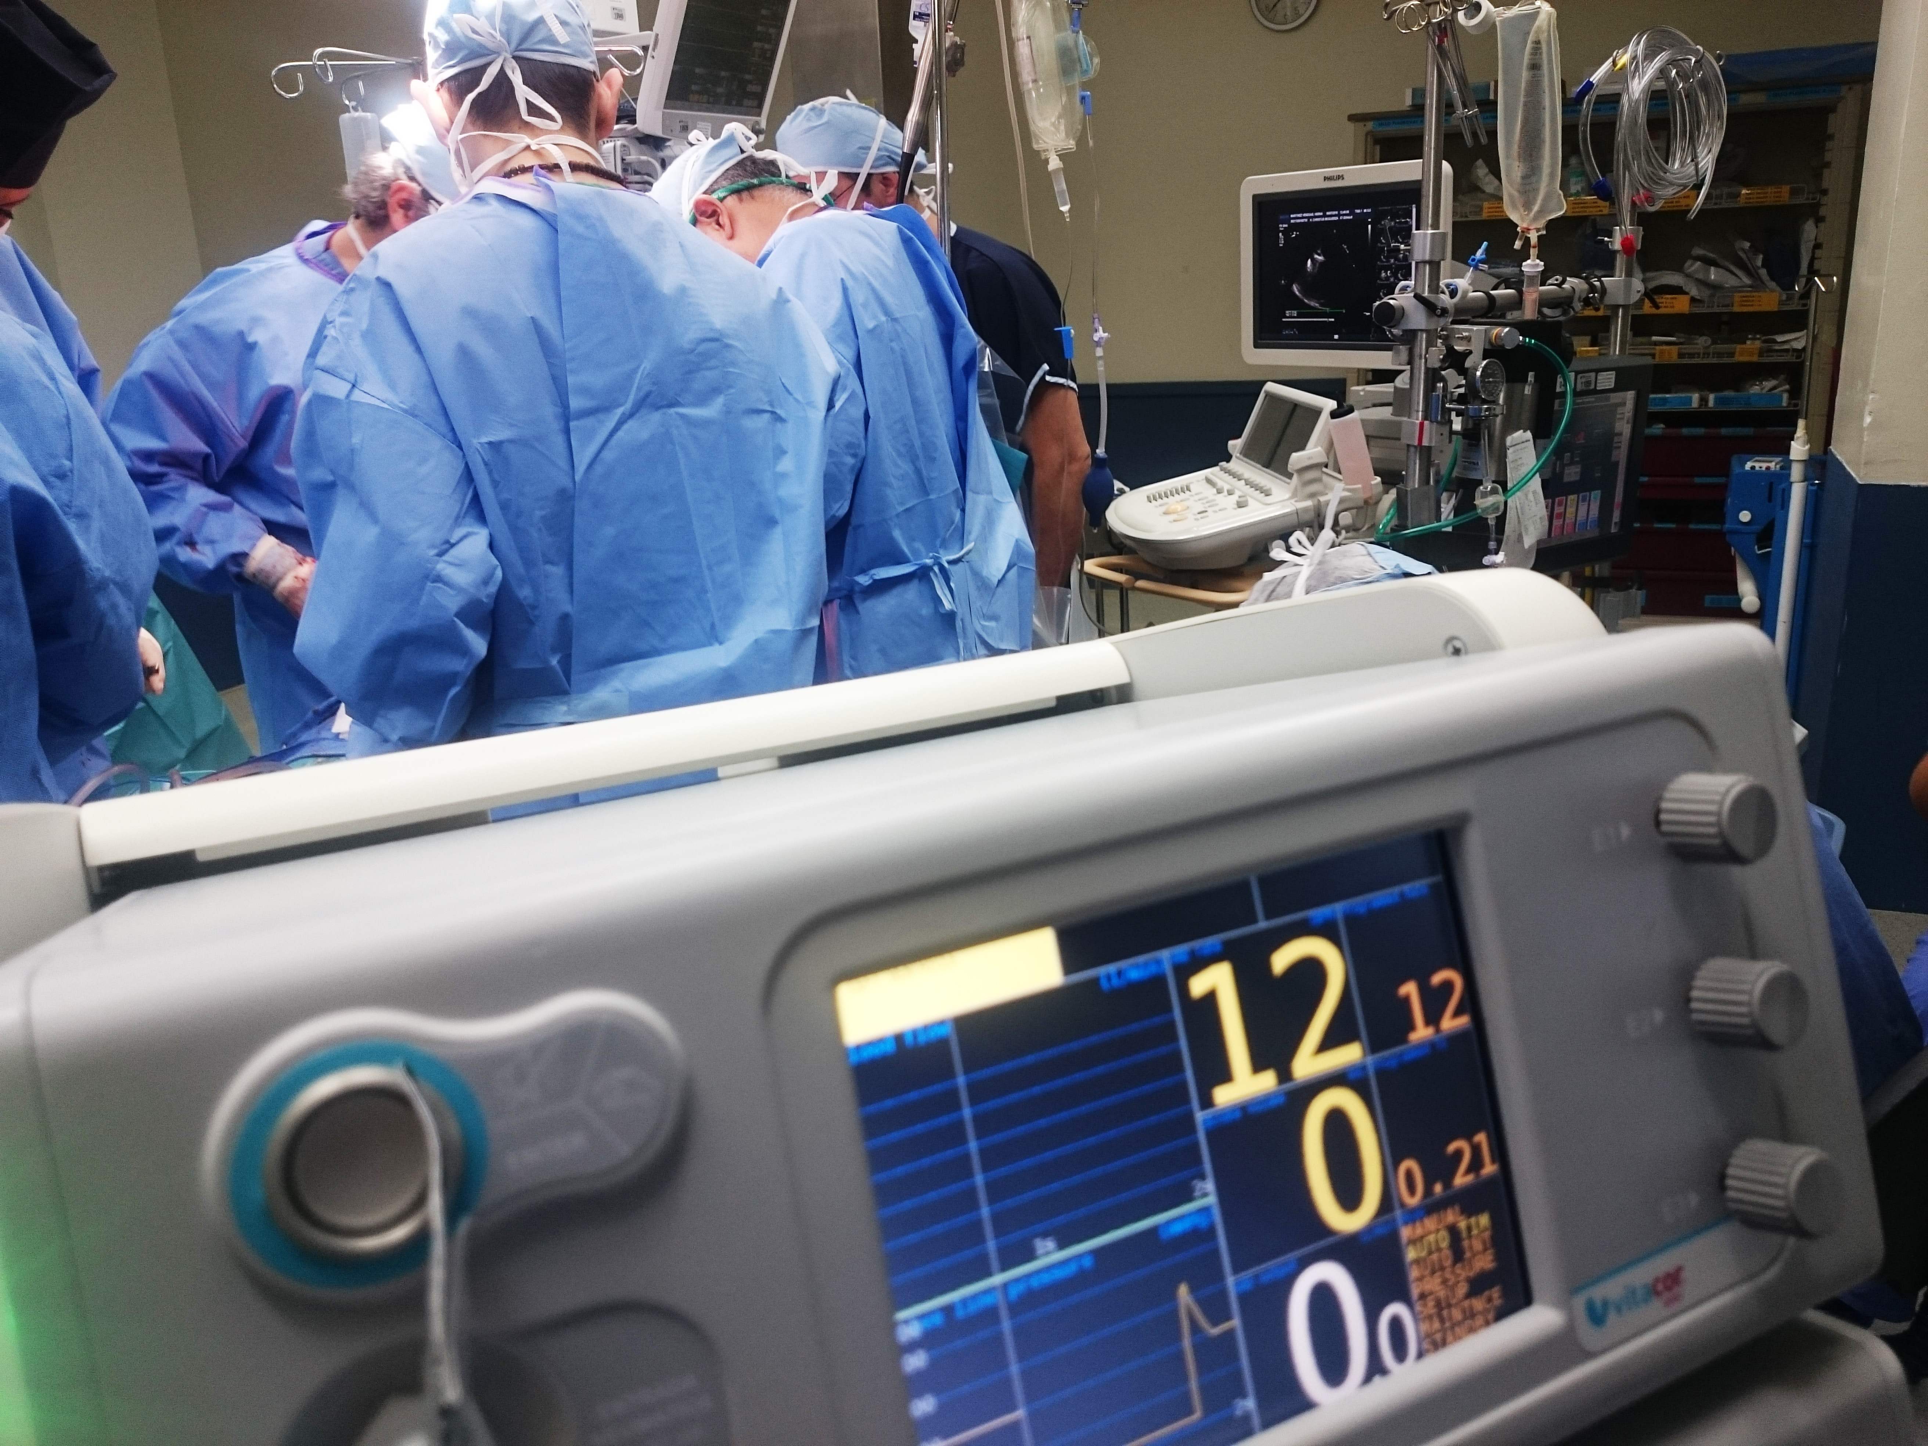

Photo by Natanael Melchor on Unsplash
https://unsplash.com/photos/43LwvC-eQPM

Photo by NeONBRAND on Unsplash
https://unsplash.com/photos/zFSo6bnZJTw

Photo by Becca Tapert on Unsplash
https://unsplash.com/photos/GnY_mW1Q6Xc

https://unsplash.com/photos/xGtHjC_QNJM
Photo by JESHOOTS.COM on Unsplash

https://unsplash.com/photos/HtBlQdxfG9k
Photo by Daniel McCullough on Unsplash

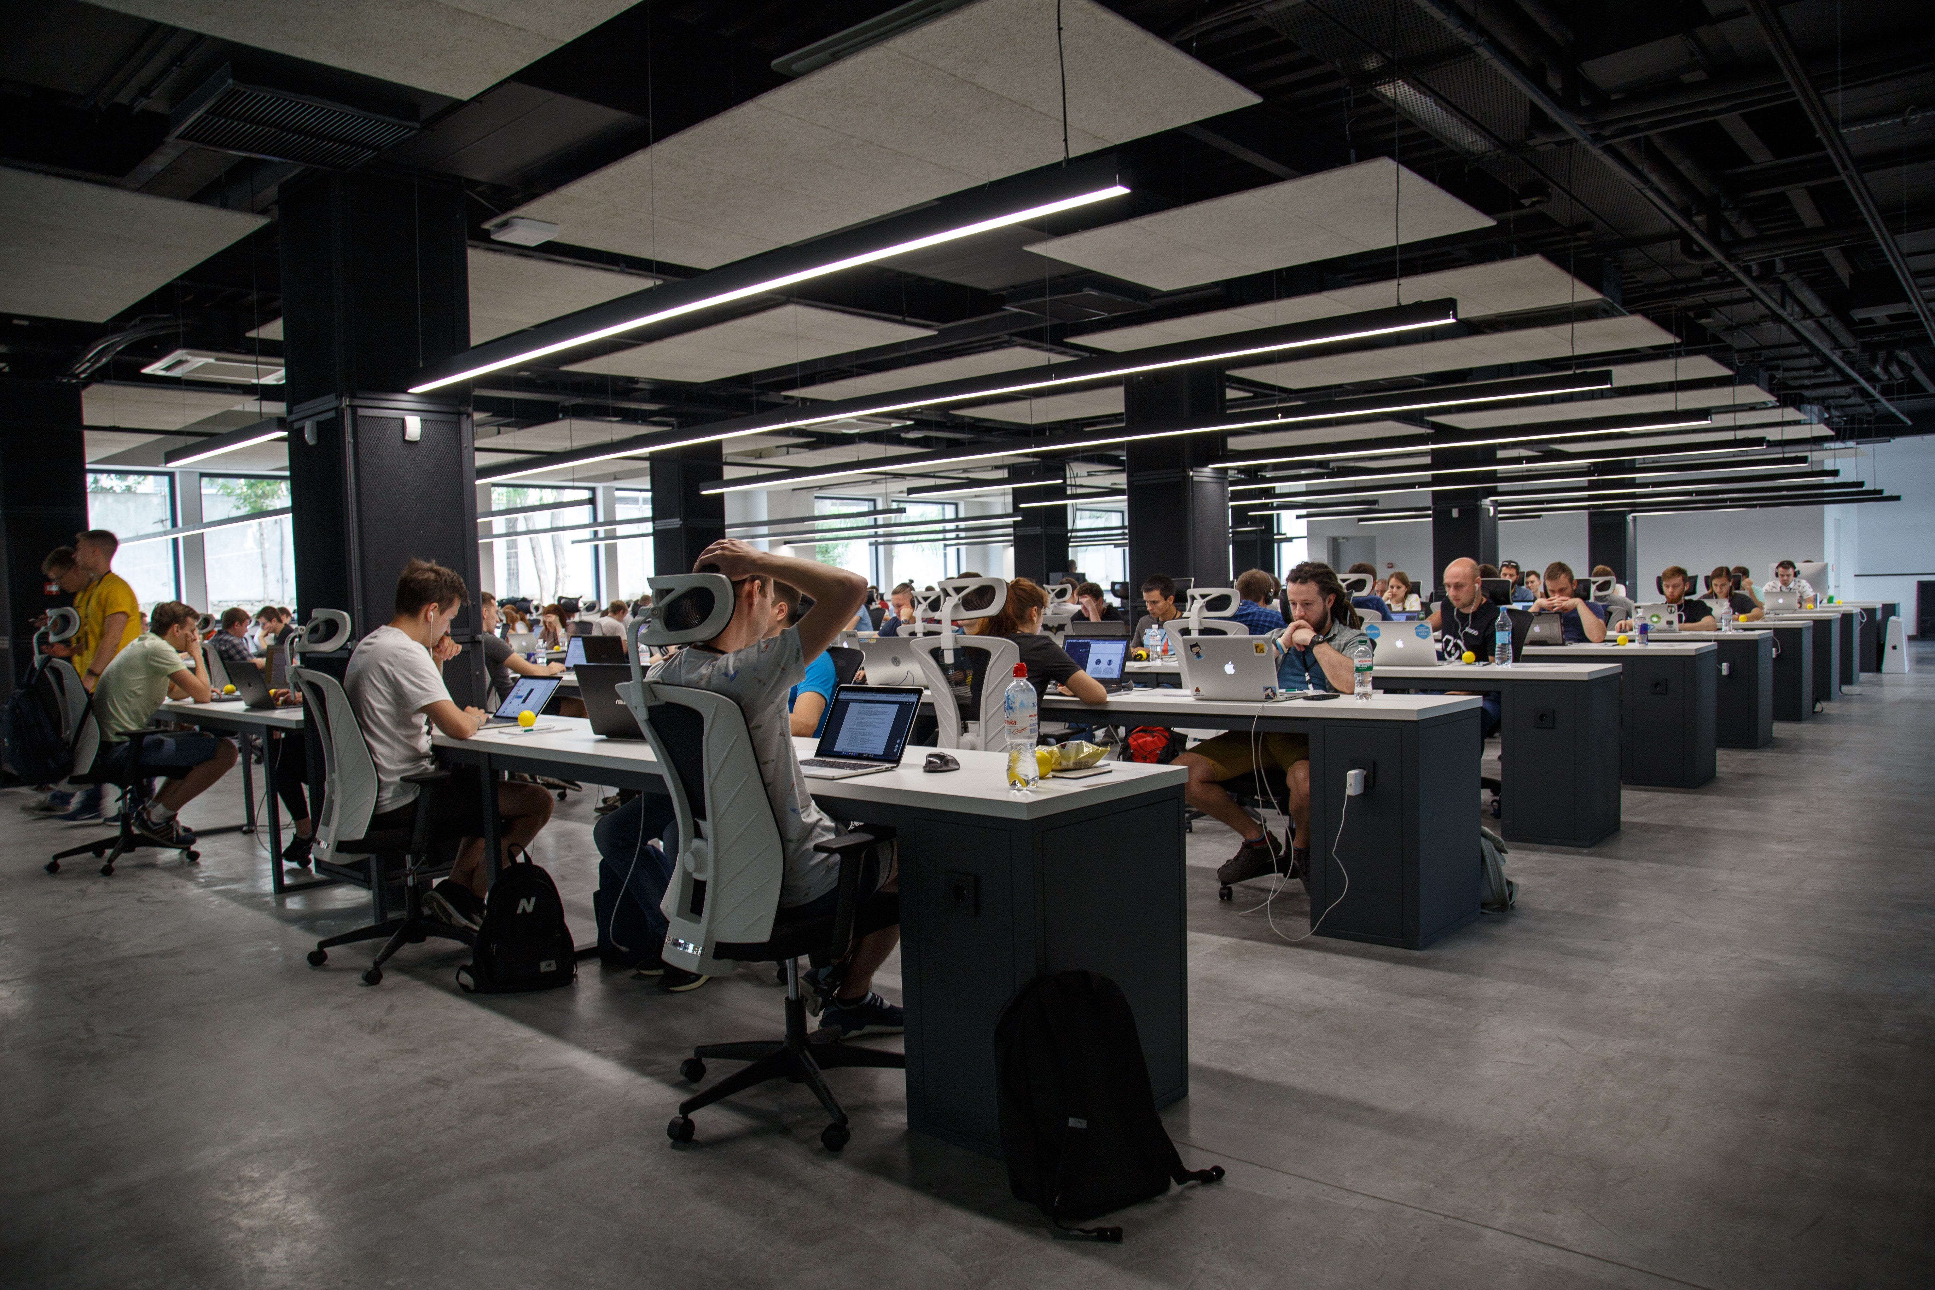

https://unsplash.com/photos/QBpZGqEMsKg
Photo by Alex Kotliarskyi on Unsplash

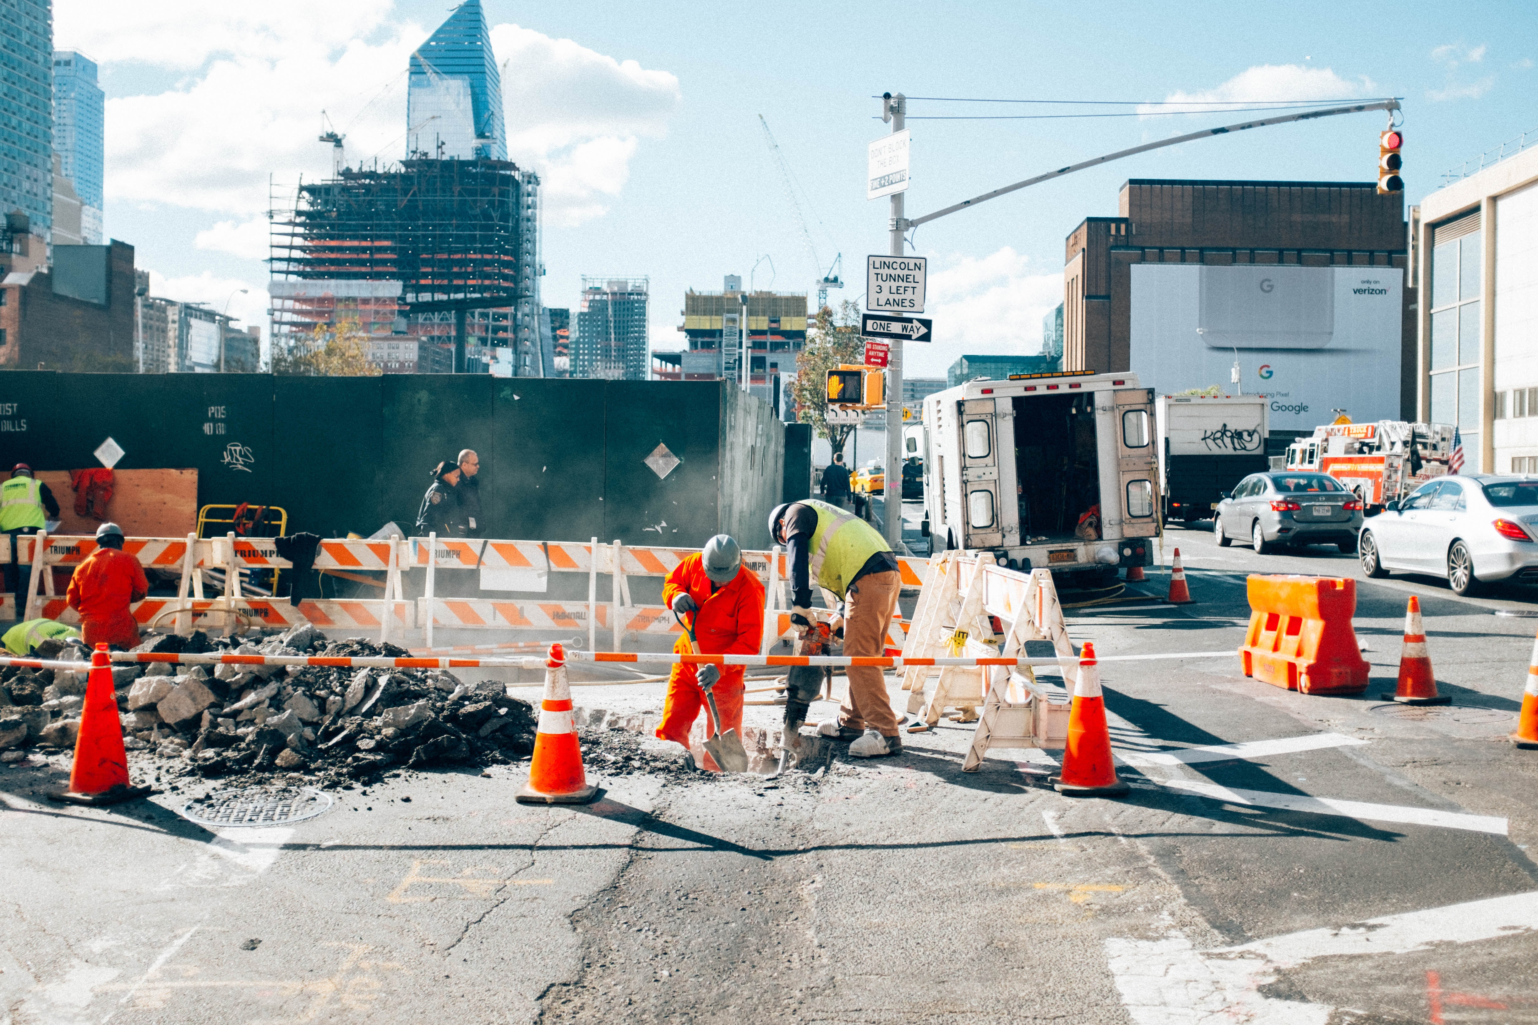

https://unsplash.com/photos/WJg2bynUWOk
Photo by Nicolas J Leclercq on Unsplash

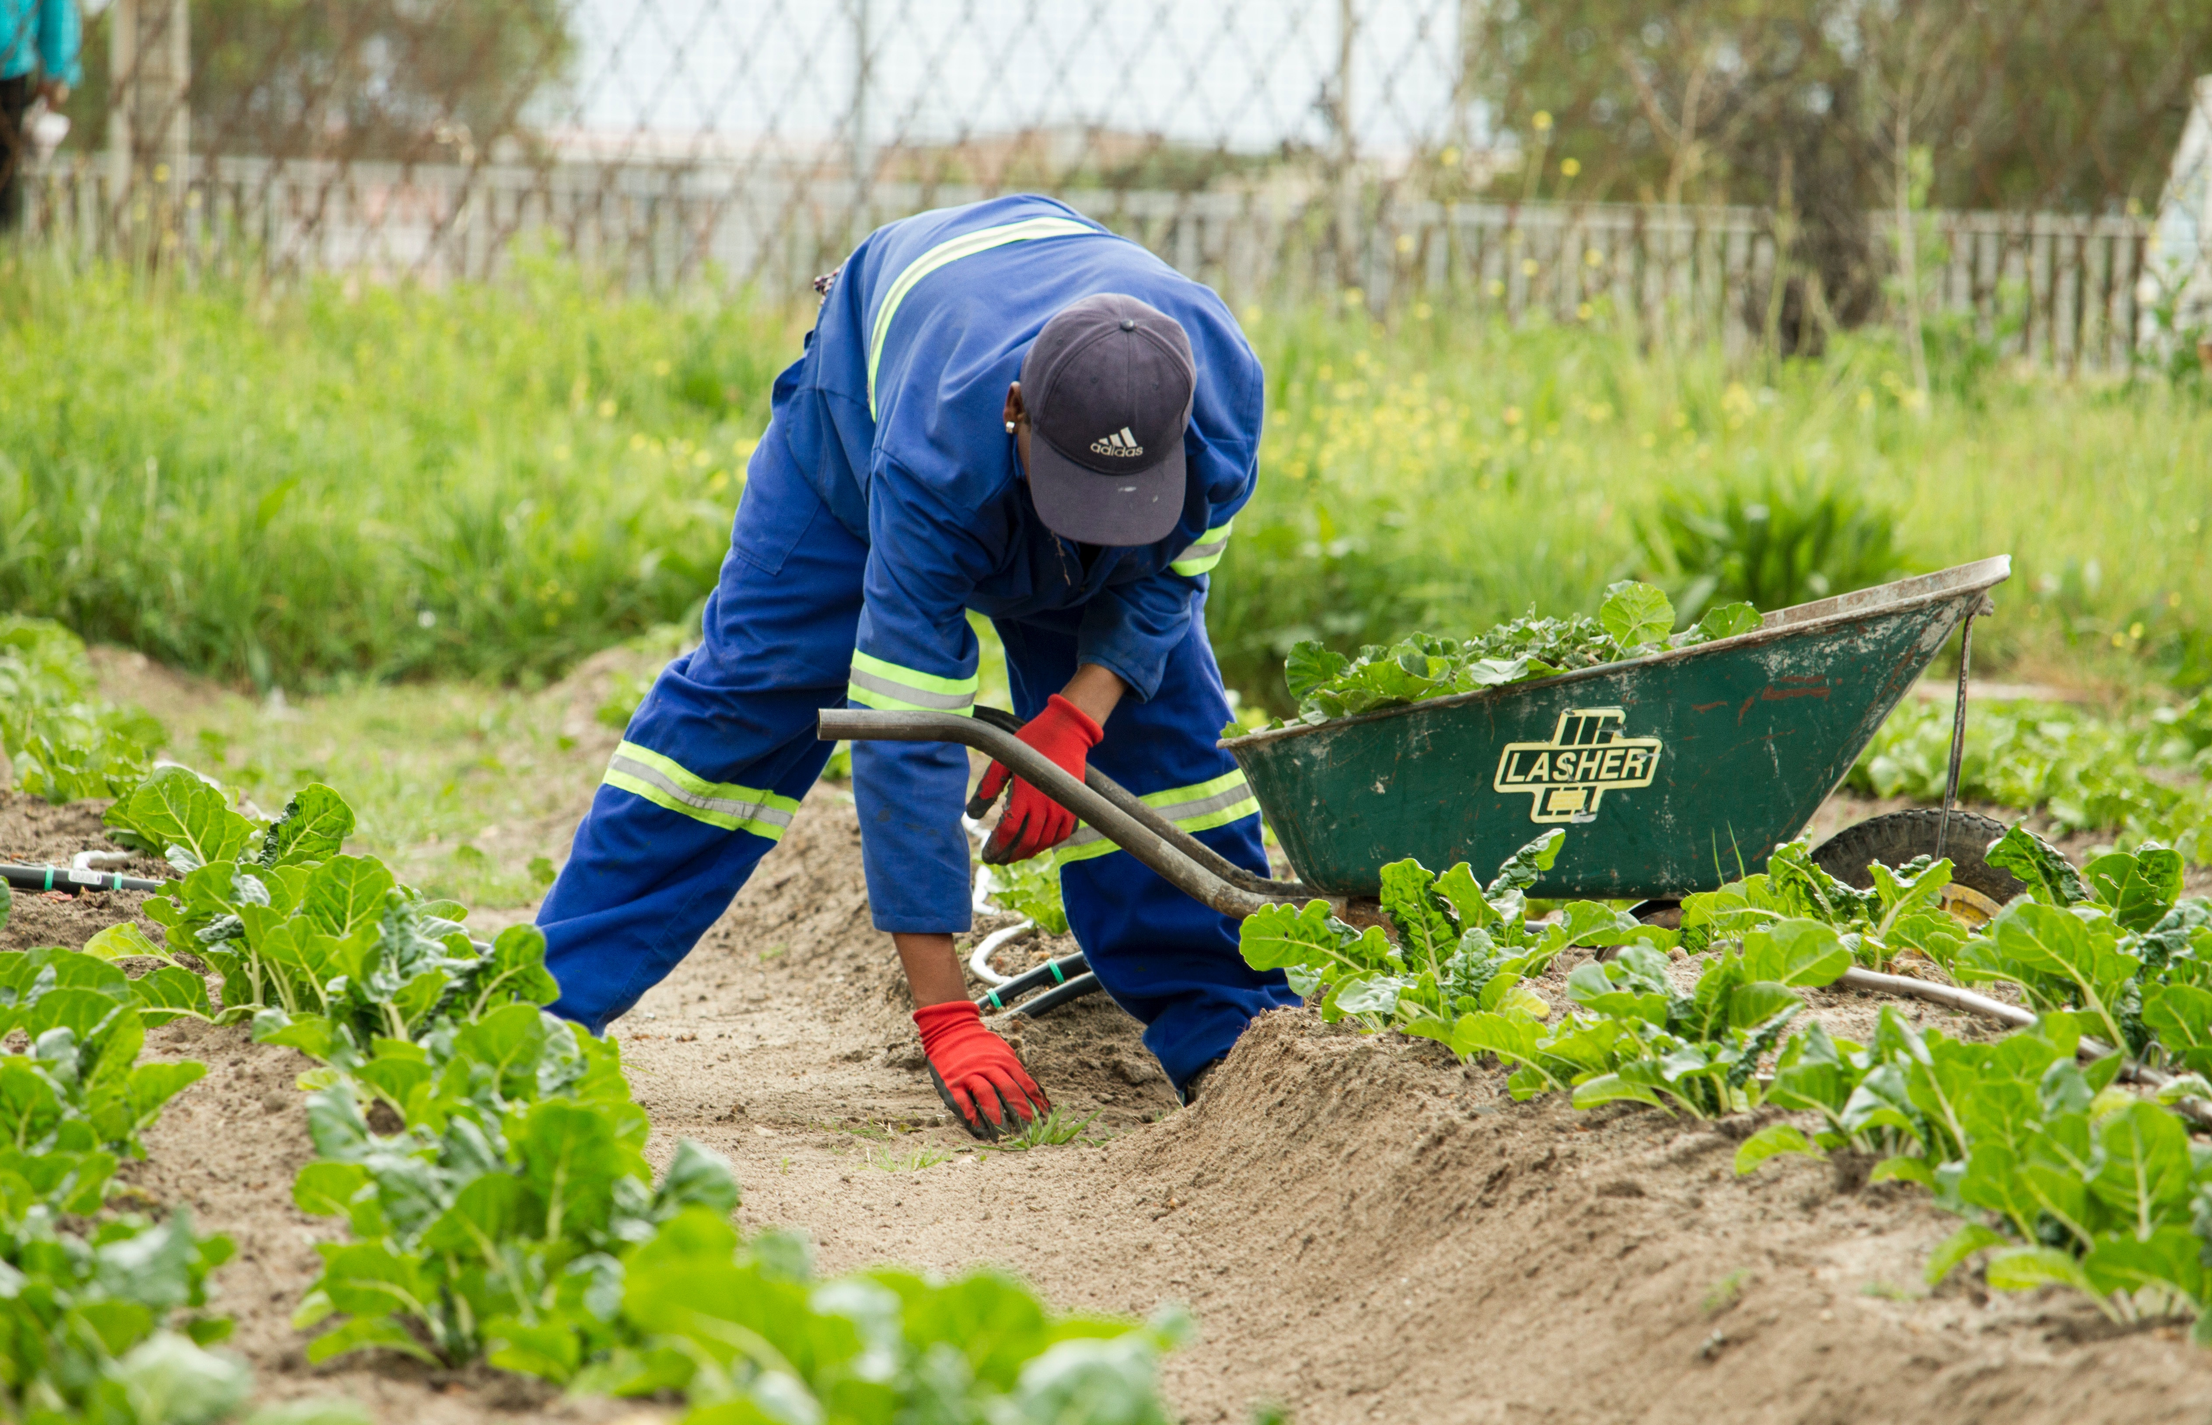

https://unsplash.com/photos/CXKk4zU7anE
Photo by Anaya Katlego on Unsplash

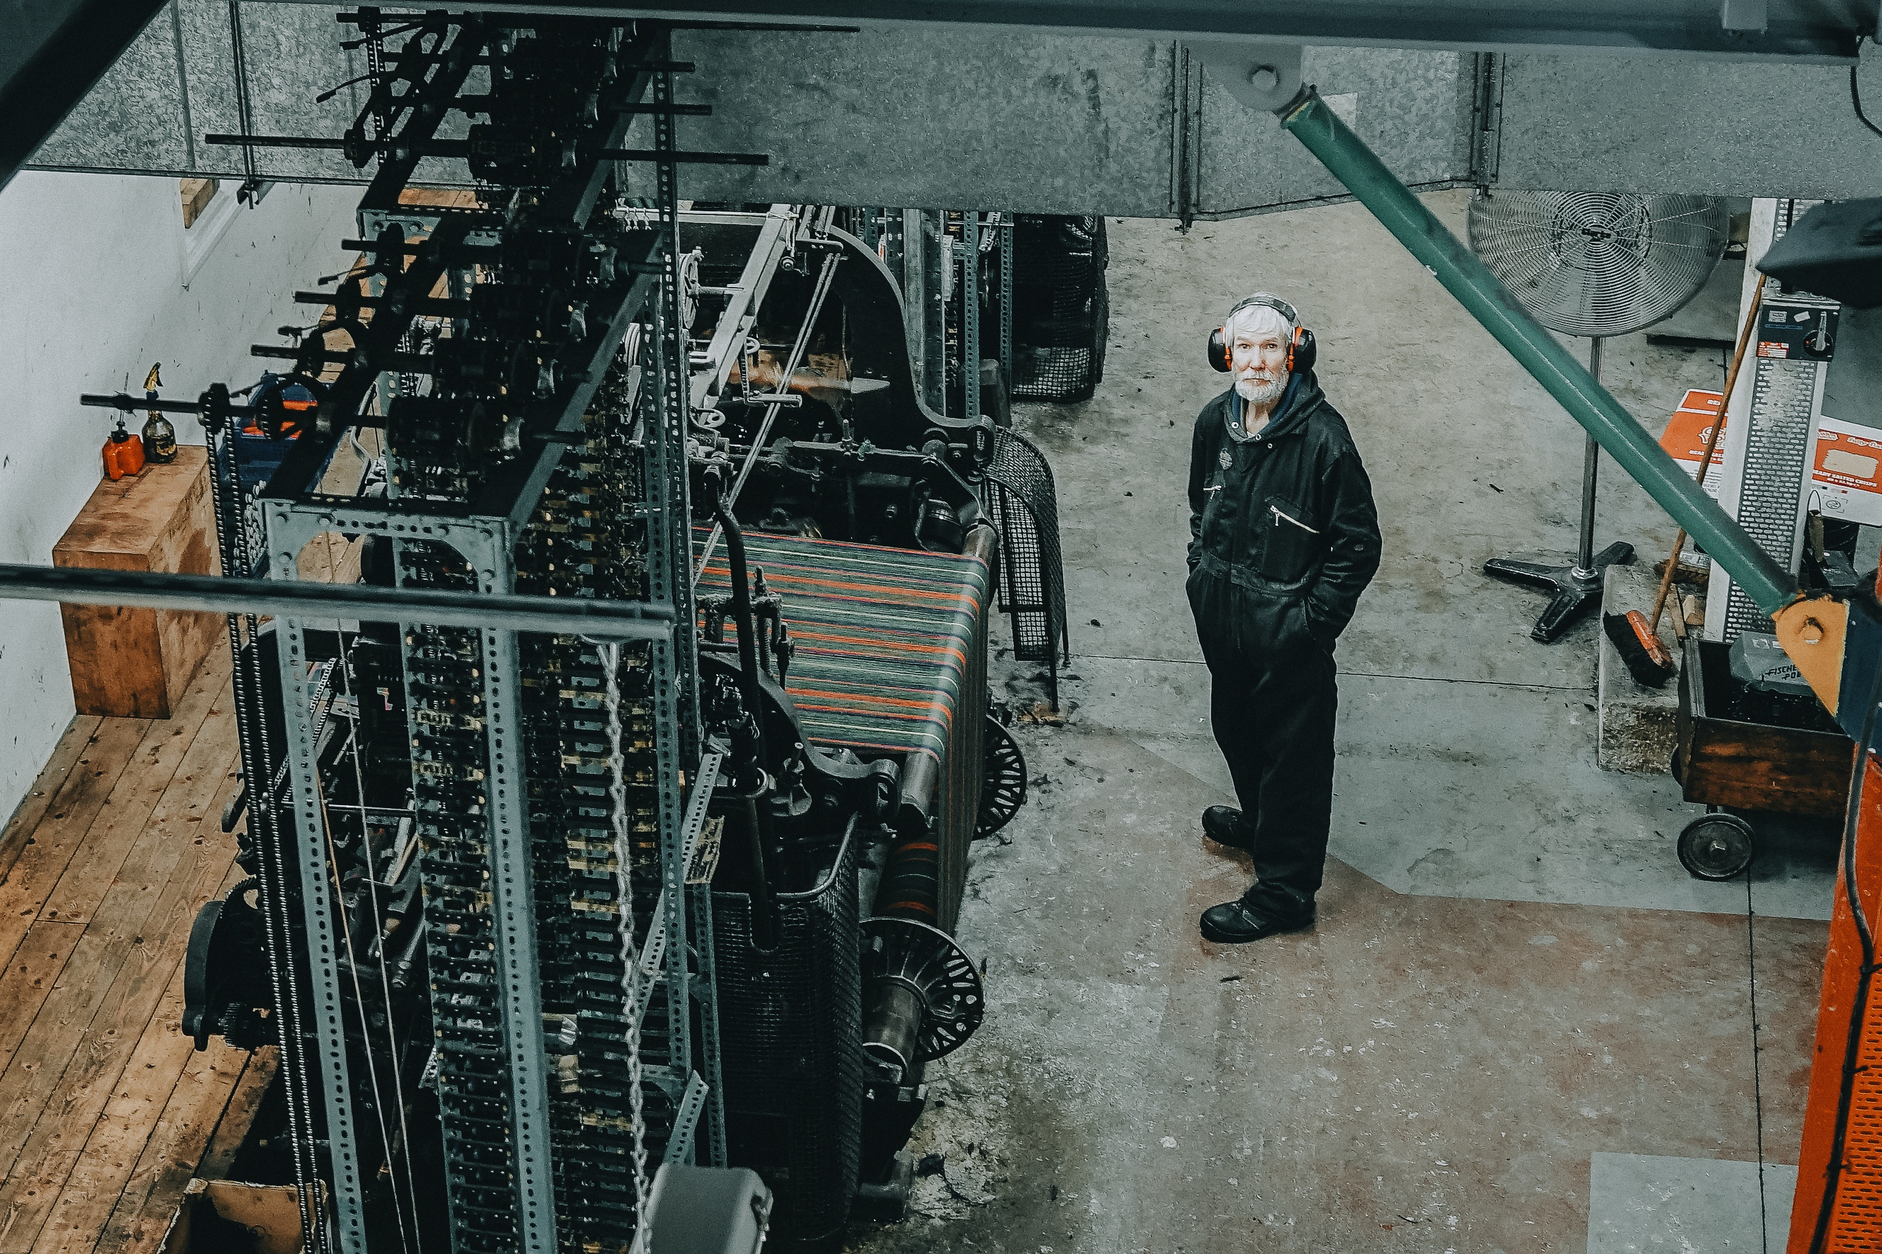

https://unsplash.com/photos/ce5LOZZvjpY
Photo by abi ismail on Unsplash

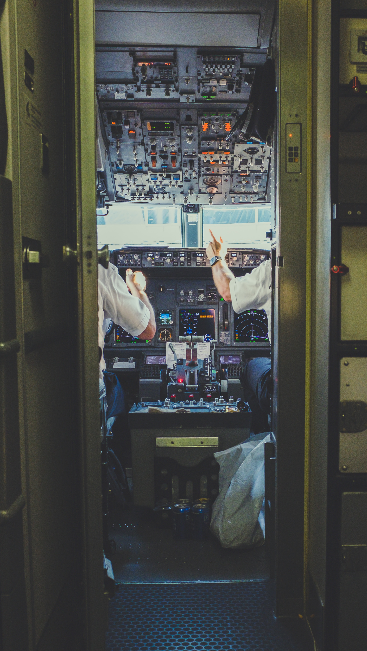

Photo by NeONBRAND on Unsplash
https://unsplash.com/photos/c56y966zOXc

https://unsplash.com/t/business-work?utm_source=unsplash&utm_medium=referral&utm_content=creditCopyText

