Vorschlag für eine mündliche Leistungsüberprüfung Niveau A1
Beispiel 4: Incontri/Mi piace - non mi piace
Sei in Italia nella famiglia della tua/del tuo corrispondente:
- Parla di te.
- Racconta che cosa ti piace / non ti piace.
Du bist in Italien in der Gastfamilie deiner Austauschschülerin/deines Austauschschülers:
Erzähle von dir. Sprich über das, was du magst und was du nicht magst.

TU

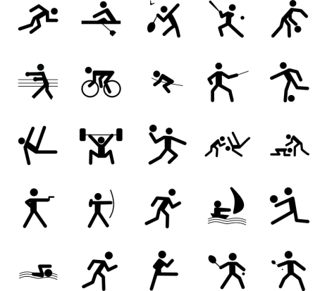
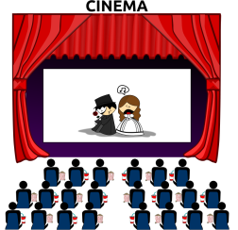

https://openclipart.org/detail/168343/cinema
https://openclipart.org/detail/24621/architetto-al-bar
https://openclipart.org/detail/82963/dance-toon
https://openclipart.org/detail/67087/rock-star-with-guitar
https://openclipart.org/detail/171405/sports-symbols
https://openclipart.org/detail/192852/thumbs-up
https://openclipart.org/detail/192850/thumbs-down

