Vorschlag für eine mündliche Leistungsüberprüfung Niveau A1/A2
Beispiel 7: Preparare una festa
Dialogo: Preparare una festa - Il compleanno di Max Partner A
È il compleanno di Max e organizzate una festa a sorpresa per lui. Mettevi d’accordo:
- Dove? Quando?
- Chi sono gli invitati?
- Cosa preparate (p.es. la pizza)? Cosa dovete comprare?
- Chi porta che cosa?
- Cosa fate durante la serata?

Erzähle von dir. Sprich über das, was du magst und was du nicht magst.

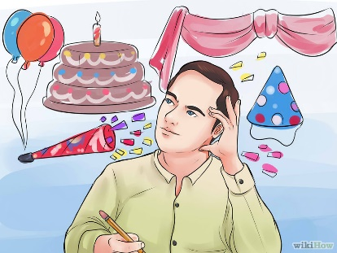

--------------------------------------------------------------------------------------------------------------------
Dialogo: Preparare una festa - Il compleanno di Max Partner B
È il compleanno di Max e organizzate una festa a sorpresa per lui. Mettevi d’accordo:
- Dove? Quando?
- Chi sono gli invitati?
- Cosa preparate (p.es. la pizza)? Cosa dovete comprare?
- Chi porta che cosa?
- Cosa fate durante la serata?

Erzähle von dir. Sprich über das, was du magst und was du nicht magst.

Bildquellen:
http://www.wikihow.com/Plan-a-Surprise-Birthday-Party#/Image:Plan-a-Surprise-Birthday-Party-Step-2-Version-3.jpg
https://openclipart.org/download/227169/Shopping-List-Clipboard.svg
https://openclipart.org/detail/8685/pizza-and-wine
https://openclipart.org/detail/190441/january-calendar-page-lets-dance

